# CS 255 System Design Document Template

This template lays out all the different sections that you need to complete for Project Two. Each section has guidance to prompt your thinking. You will need to continually reference the interview transcript as you work to make sure that you are addressing your client’s needs. There is no required length for the final document. Instead the goal is to complete each section based on what your client’s needs are. Remove this note when you are finished, and replace all bracketed text with the relevant information.

## UML Diagrams

### UML Use Case Diagram

### UML Activity Diagrams

**1.**

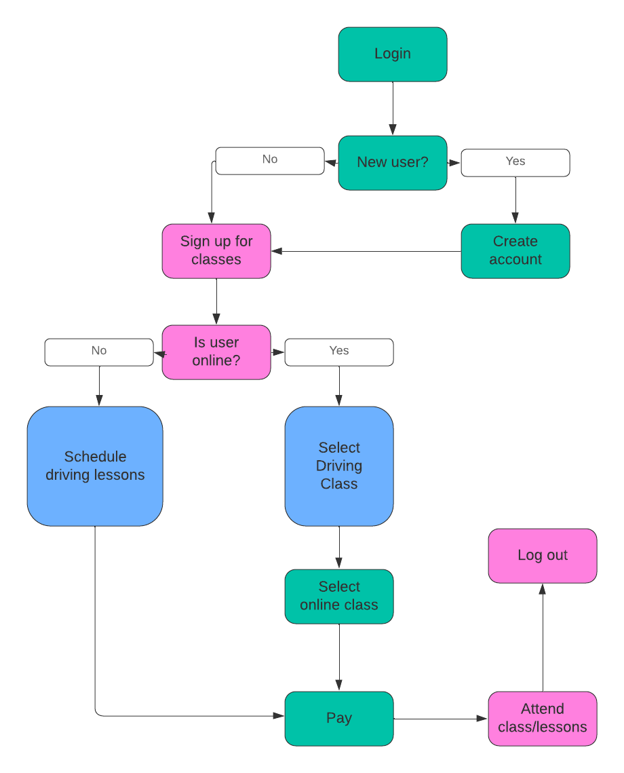

**2.**

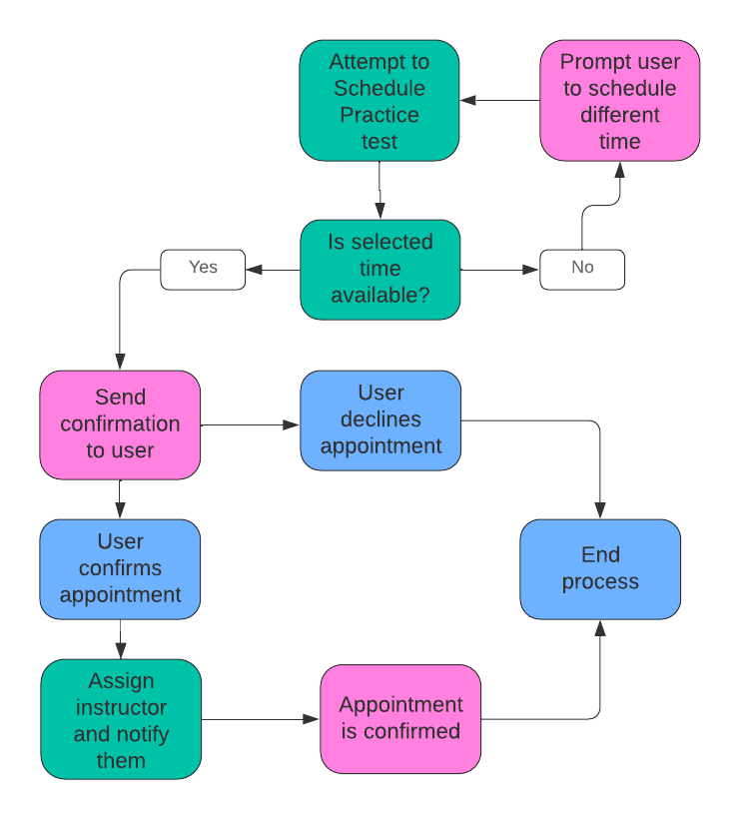

### UML Sequence Diagram

### UML Class Diagram

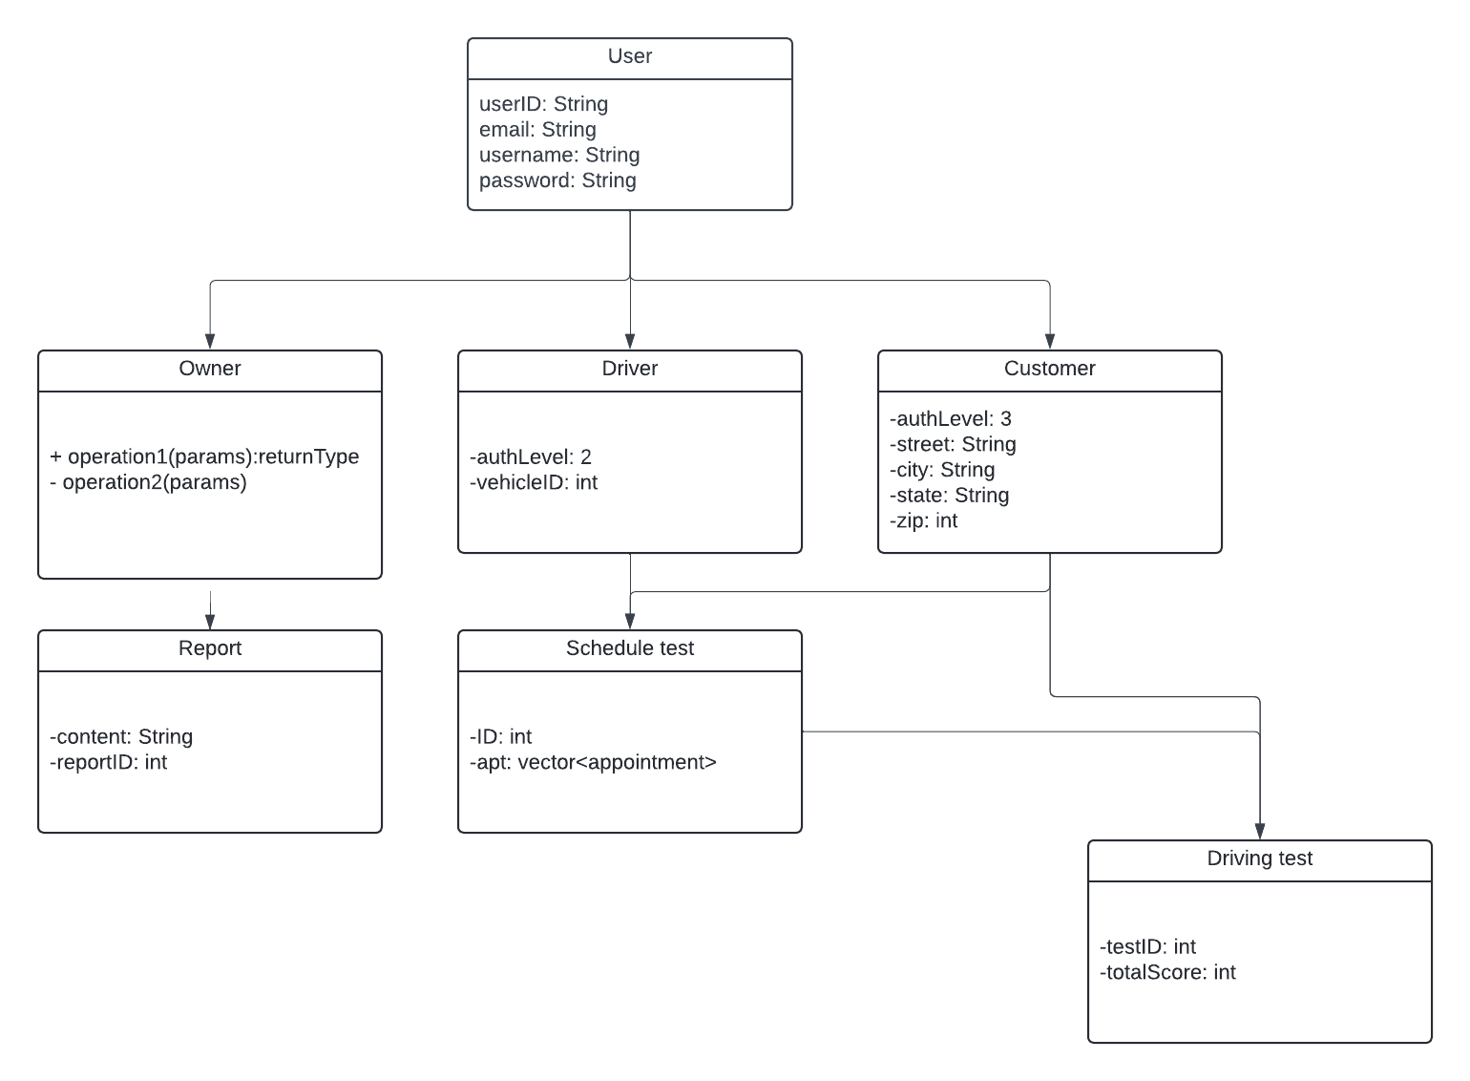

## Technical Requirements

Host Hardware Specifications:

Minimum of one standalone server

Networking cables to connect the server and other devices

Peripheral devices including a monitor, keyboard, and mouse for direct interaction

Adequate power supply units

An internet connection service

Client Hardware Specifications:

A desktop or laptop computer

Networking solutions such as a Wi-Fi Router or an ethernet cable

Reliable power supply units

An internet connection service

Software Specifications for the Host:

The host should run on a Windows Server operating system

DriverPass Software for operational management

Docker for managing virtual machine (VM) network traffic

Cybersecurity solutions to safeguard against unauthorized access or breaches

Software Specifications for the Client:

A web browser (e.g., Firefox, Chrome)

A compatible operating system (e.g., Mac OS, Linux, Windows)

Cybersecurity tools to protect against data theft or malware

Development Tools:

Computers equipped with development software (such as Visual Studio, Eclipse)

An internet connection for uploading content to the server

Network administration tools for identifying and managing suspicious network activity

Infrastructure Needs:

A dedicated physical location for the server or a subscription with a cloud service provider

These specifications are designed to ensure that both the host and client sides of the system are equipped with the necessary technology to support efficient, secure, and reliable operation.